History Restaged  24 April - 31 May, 2015  Participants: Carlos Amorales (MX), Heidrun Holzfeind (A), Sven Johne (GER), Meiro Koizumi (JP), Susanne Kriemann (GER), Zbigniew Libera (PL), Maha Maamoun (EG), Roee Rosen (IL),  Clemens von Wedemeyer (GER)  Curators: Molnár Edit and Páldi Lívia | 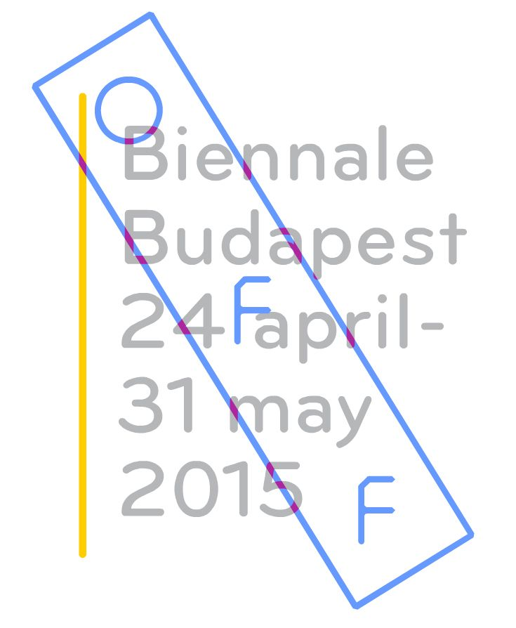

Venues:  OSA Archivum  Budapest V. Arany János u. 32.  Opening: 24 April, 6pm. | Platan Gallery (Polish Institut, Budapest)  Budapest, 1061 Andrássy út 32.  Opening: 24 April, 5pm  Zbigniew Libera (PL), Sven Johne (DE)

History Restaged brings together artists whose practices address the necessity of critical thinking and of individual and collective responsibility. Employing strategies of re-staging, where the line between documentary and fiction ceases to exist, the selected works use filmic, literary, archival and art historical references to revisit historically significant events and unsettle our conventional notions of reality.
Staged within the current oppressive political and social milieu in Hungary, the exhibition project is particularly interested in the artistic strategies of fictionalization where the line between documentary and fiction collapses, often using filmic and art historical references, and archival and documentary materials. Some of these strategies subvert our expectations regarding established narratives through staged reconstruction, reenactments, estrangement, humor and irony. They engage with the rethinking of recent historical events by referring to certain works of art and film historical pieces, with the help of archival materials and literature.

Apart from the piece by Susanne Kriemann ( 22756) that recalls the Berlin Blockade the first gigantic conflict of the Cold War, in an arial photo-series from 2012 , and the self-portrait photo-diptych by Zbigniew Libera (Freelancer- Self-portrait, 2013) that depicts the artist as a despised outcast of society, the artworks in the exhibition are mainly videos or installations based on moving images. The historical film references, the stressing of the representation and application of technical nuances and different methods of filmmaking were not merely expressive inspirations for the artists but rather critical tools.

Sven Johne (Some Engels, 2013) instrumentalized the basic repetitive nature of the casting interview in his works to examine sensitive and contradictory historical questions. The video Some Engels, which analyzes the legacy of the DDR - from the perspective of the present, after the literal disappearance of that state - is balanced on the edge of tragicomedy. That special sensitivity towards the comical in less than comic contexts connects it with the video installation by Meiro Koizumi (It´s a Comedy, 2012) which thematizes the openly nationalistic way in which mainstream politics deals with the Japanese participation in the Second World War.

In the works by Heidrun Holzfeind (Mexico 68, 2007) and Carlos Amorales (Supprimer, Modifier et Preserver, 2012) the interview, as a basic tool of documentary filmmaking and television, has a central role. The installation by Holzfeind juxtaposes the archival photo material on the Mexican student revolt in 1968 with several interviews that were conducted with a student-activist 40 years after the events, while the focus of the piece by Amorales is a challenge to our understanding of civic law as the rational and complete system that regulates society.

The essential question that unites the artists of History Restaged is how accurate and critical reflections on the political or social problems can be made from the perspective of today, through the deep investigation of historical events from the not so distant past. The Israeli-American painter, filmmaker and writer Roee Rosen often mixes reality with fiction in a grotesque and highly provocative way. The relationship between identity and trauma, between power and evil, stands in the focal point of his oeuvre. The installation is a selection from the video works of an artist collective of ex-soviet emigrant writers and filmmakers founded by a fictitious poet and artist named Maxim Komar-Miskin. The fake-documentaries produced by the group (The Buried Alive Videos, 2013) are perfectly built social satires involving numerous literary, historical and political references, targeting consumer fetishism, media-manipulation and political violence.

The Cairene Maha Maamoun’s artistic practice has often been concerned with deconstructing and re-imagining iconic and populist visual representations taken from mainstream Egyptian culture - national advertising, popular film, postcards, and contemporary literature. In her 2011 work Night Visitor – The Night of Counting the Years she edited together live footages posted on YouTube by different people. The images were produced from low-resolution mobile phone cameras and documented the break-in to the State Security building in the months following the first wave of the 2011 revolution. Maamoun’s piece 2026 (2010) merges two separate dystopias when she uses the citations from a novel entitled Revolution 2053 by the Egyptian writer Mahmud Osman as subtitles for the iconic scenes of Chris Marker’s Le jettee.

Edit Molnár and Lívia Páldi

The exhibition is part of the OFF –Biennále, Budapest.
http://offbiennale.hu
Supported by: Open Society Foundations; Polish Institute, Budapest; OSA Archivum; Austrian Cultural Forum, Budapest; Goethe Institute, Budapest; BAC–Baltic Art Center, Visby;
Private Donors

